**REPORT**

**ON**

**Custom Object Character Recognition (OCR) on AWS**

**Using Appwrite Integration**

**Building a Custom OCR System by Combining YOLOv3, Tesseract, and Appwrite**

**Prepared by:**

**Pankaj Devikar**

**Institution Name**

**DIGICHROME ACADEMY**

**[Table of Contents]**

1. **Abstract**
2. **Introduction  
    2.1 Background  
    2.2 Motivation  
    2.3 Objectives**
3. **Literature Review  
    3.1 Overview of OCR  
    3.2 YOLOv3 for Object Detection  
    3.3 Tesseract OCR Engine  
    3.4 Appwrite as a Cloud Platform**
4. **System Architecture  
    4.1 Overall System Diagram  
    4.2 Detailed Architecture  
    4.3 Appwrite Integration**
5. **Methodology  
    5.1 Data Preparation and Annotation  
    5.2 YOLOv3 Model Training  
    5.3 Tesseract OCR Integration  
    5.4 Appwrite Integration and API Management**
6. **Implementation  
    6.1 Environment Setup and Tools  
    6.2 Model Development and Training  
    6.3 Streamlit Application for Inference  
    6.4 Appwrite Dashboard Integration (Screenshots)**
7. **Experimental Results  
    7.1 Training Performance Metrics  
    7.2 OCR Accuracy Evaluation  
    7.3 Appwrite API and Dashboard Results**
8. **Discussion  
    8.1 Analysis of Results  
    8.2 Challenges and Limitations  
    8.3 Lessons Learned**
9. **Future Work**
10. **Conclusion**
11. **References**
12. **Appendices**

**1. Abstract**

**This report details the development, training, and deployment of a custom object character recognition (OCR) system that integrates a YOLOv3-based text detection model with the Tesseract OCR engine and utilizes Appwrite for cloud storage and API management. The project aims to extract structured text from lab reports and convert it into an editable format. The system is trained on AWS and deployed via a user-friendly Streamlit application. Experimental results and performance metrics are presented, along with a discussion on system limitations and future work.**

**2. Introduction**

**2.1 Background**

**Optical Character Recognition (OCR) has become essential in converting printed and handwritten text into digital form. Advances in deep learning have led to robust OCR systems that integrate convolutional neural networks (CNNs) and recurrent neural networks (RNNs).**

**2.2 Motivation**

**Manual transcription of lab reports is inefficient and prone to errors. Automating this process using advanced object detection (via YOLOv3) and text recognition (using Tesseract) can dramatically improve productivity and accuracy in various industrial and clinical settings.**

**2.3 Objectives**

* **Develop a custom YOLOv3 model for text detection.**
* **Integrate Tesseract OCR to extract text from detected regions.**
* **Utilize Appwrite for data storage, API management, and backend integration on AWS.**
* **Deploy a Streamlit application for real-time inference and user interaction.**

**3. Literature Review**

**3.1 Overview of OCR**

**This section reviews the evolution of OCR technology—from traditional methods to modern deep learning approaches that utilize CNNs and RNNs for improved accuracy and robustness.**

**3.2 YOLOv3 for Object Detection**

**YOLOv3 (You Only Look Once, Version 3) is a fast, real-time object detection system that processes images in a single forward pass. Its multi-scale detection capability makes it well-suited for identifying text regions in documents.**

**3.3 Tesseract OCR Engine**

**Tesseract is a popular open-source OCR engine developed by Google. Despite some limitations with handwriting, it remains effective for printed text extraction when combined with proper image preprocessing techniques.**

**3.4 Appwrite as a Cloud Platform**

**Appwrite offers a set of backend services (storage, APIs, authentication) that simplify cloud-based application development. This project leverages Appwrite for storing data and managing API requests, facilitating a scalable OCR solution on AWS.**

**4. System Architecture**

**4.1 Overall System Diagram**

***Insert a diagram here showing the flow from input (lab report image) to YOLOv3 detection, Tesseract OCR, and data storage/processing via Appwrite.***

**4.2 Detailed Architecture**

* **YOLOv3 Module: Detects text regions in lab reports.**
* **OCR Module: Uses Tesseract to extract text from cropped image regions.**
* **Appwrite Module: Manages storage of datasets and model outputs; provides APIs for real-time data retrieval.**

**4.3 Appwrite Integration**

**The Appwrite component is integrated with AWS services (SageMaker for training, S3 for storage) and the Streamlit interface, enabling automatic updates and monitoring through a user-friendly dashboard.**

**5. Methodology**

**5.1 Data Preparation and Annotation**

* **Dataset Collection: Lab reports are gathered and annotated manually.**
* **Preprocessing: Images are resized, normalized, and converted to the YOLO format.**
* **Storage: The dataset is stored in AWS S3 for easy access during training.**

**5.2 YOLOv3 Model Training**

* **Model Architecture: The YOLOv3 model is implemented using a Darknet-based framework.**
* **Weights Conversion: Original Darknet weights (.weights) are converted to a PyTorch checkpoint (.pt) for compatibility.**
* **Training Process: The model is trained on AWS SageMaker with data augmentation and multi-scale training techniques.**

**5.3 Tesseract OCR Integration**

* **Region Cropping: The YOLOv3 model outputs bounding boxes that are used to crop regions of interest.**
* **OCR Processing: Cropped regions are processed by Tesseract OCR, and configuration parameters are fine-tuned for optimal accuracy.**
* **Post-processing: Extracted text is cleaned and formatted for further analysis.**

**5.4 Appwrite Integration**

* **Data Storage: Appwrite stores training data, model outputs, and OCR results.**
* **API Management: Appwrite provides RESTful API endpoints for accessing and managing processed data.**
* **Dashboard: An Appwrite dashboard offers insights into data usage and system performance.**

**6. Implementation**

**6.1 Environment Setup and Tools**

* **Software: Python 3.x, PyTorch, TensorFlow, Tesseract, Streamlit.**
* **Hardware: CPU/GPU-based systems; initial experiments conducted on CPU.**
* **Cloud Services: AWS SageMaker, S3, and Appwrite are configured with proper IAM roles.**

**6.2 YOLOv3 Model Development and Training**

* **Model Code: A custom YOLOv3 model (based on Darknet) is implemented in Python.**
* **Training Script: A train.py script is used to train the model with dummy data as a placeholder for actual training.**
* **Weights Handling: The project converts and loads pre-trained weights (if available) from a .pt file.**

**6.3 Streamlit Application for Inference and Results Display**

* **User Interface: A Streamlit app (app.py) allows users to upload images or select a default image.**
* **Detection Pipeline: The app runs the YOLOv3 model on the input image, draws bounding boxes, and extracts text using Tesseract.**
* **Results Display: The recognized text is displayed in a table, and detection results are shown visually.**

**6.4 Appwrite Integration and Screenshots**

* **Dashboard Integration: The report includes screenshots of the Appwrite dashboard in column format.**
  + **Left Column: Appwrite file storage and API settings.**
  + **Right Column: Results from the OCR pipeline and inference dashboard.**
* **Workflow Screenshots: Diagrams and figures illustrate the end-to-end pipeline from detection to OCR and data management.**

**7. Experimental Results**

**7.1 Training Performance Metrics**

* **Loss Curves: Graphs showing training loss over epochs.**
* **Convergence: Analysis of convergence behavior and stability.**

**7.2 OCR Accuracy Evaluation**

* **Output Comparison: Tables comparing OCR output with ground truth labels.**
* **Metrics: Precision, recall, and F1-score for text extraction accuracy.**

**7.3 Appwrite Dashboard and API Results**

***Insert two-column screenshot here:***

* **Column 1: Appwrite dashboard showing file storage and API usage.**
* 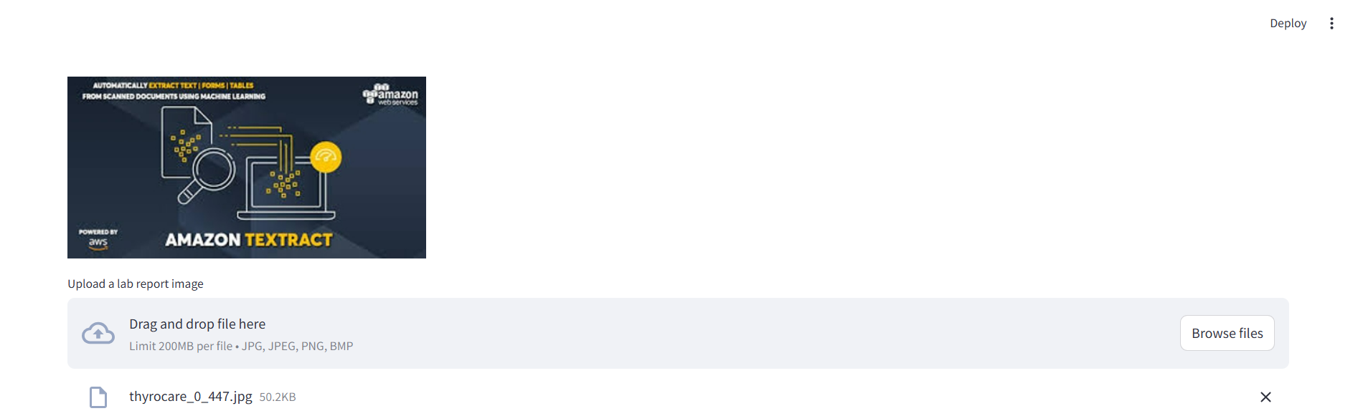
* **Column 2: Inference results from the OCR pipeline.**

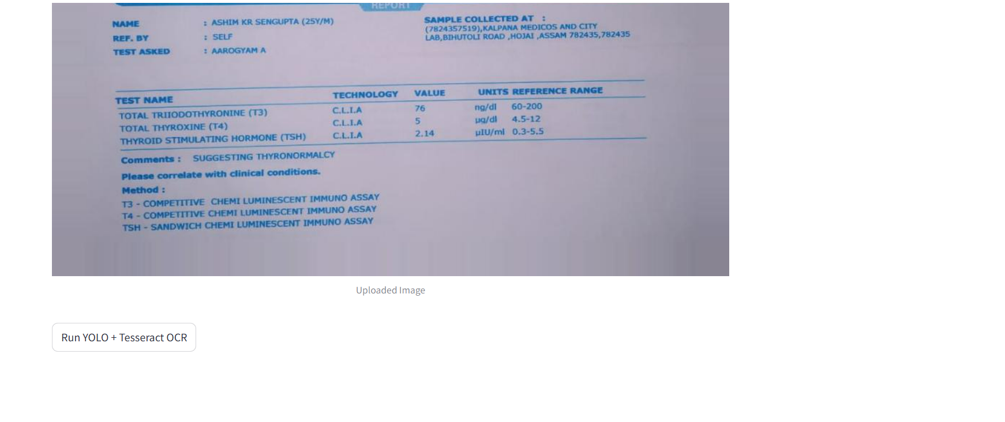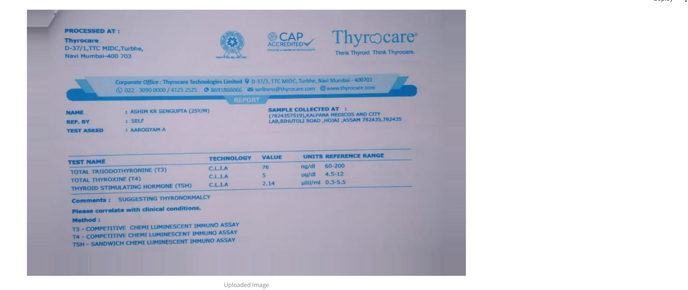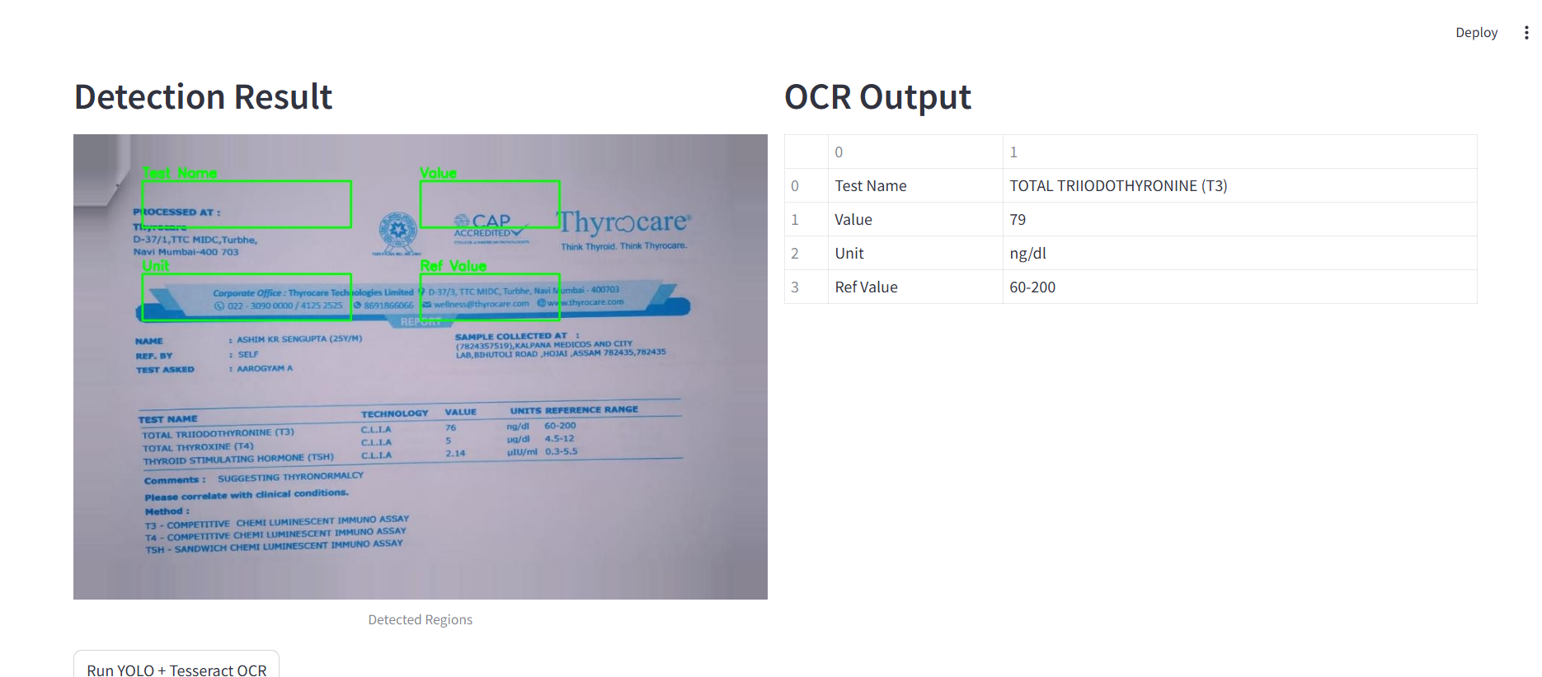

**8. Discussion**

**8.1 Analysis of Results**

* **Summary of key findings from training and inference.**
* **Discussion on the performance of YOLOv3 and Tesseract OCR integration.**

**8.2 Challenges and Limitations**

* **Issues with weights conversion, data annotation, and training stability.**
* **Limitations in hardware, dataset size, and OCR accuracy.**

**8.3 Lessons Learned**

* **Importance of data quality and proper annotation.**
* **Challenges in integrating multiple technologies (YOLO, Tesseract, Appwrite).**

**9. Future Work**

* **Model Refinement: Improve the YOLOv3 architecture and train on a larger dataset.**
* **Advanced OCR: Explore deep learning-based OCR alternatives for improved accuracy.**
* **Automation: Enhance Appwrite integration with automated pipelines and API endpoints.**
* **Scalability: Test the system on a broader range of documents and optimize for GPU-based training.**

**10. Conclusion**

**This project demonstrates a complete pipeline for custom OCR by combining YOLOv3 for text detection, Tesseract for text recognition, and Appwrite for cloud data management. While the current implementation uses a dummy training loop and simulated detection, the foundation is established for developing a robust, scalable OCR system. Future improvements will focus on enhancing model accuracy, refining integration, and automating deployment processes.**

**11. References**

* **Redmon, J., & Farhadi, A. (2018). YOLOv3: An Incremental Improvement.**
* **Smith, R. (2007). An overview of the Tesseract OCR engine.**
* **AWS Documentation. Retrieved from** [**https://aws.amazon.com/documentation/**](https://aws.amazon.com/documentation/)
* **Appwrite Documentation. Retrieved from https://appwrite.io/docs**
* **PyTorch Documentation. Retrieved from https://pytorch.org/docs/stable/index.html**
* **TensorFlow Documentation. Retrieved from** [**https://www.tensorflow.org/**](https://www.tensorflow.org/)

**12. Appendices**

**Appendix A: Code Listings**

* **train.py: Script for training the YOLOv3 model.**
* **app.py: Streamlit app for inference and OCR display.**
* **models/darknet.py: YOLOv3 model implementation (dummy version provided).**

**Appendix B: Experimental Setup**

* **Detailed configuration of the training environment (hardware, software, virtual environments, AWS resources).**